Dream catcher

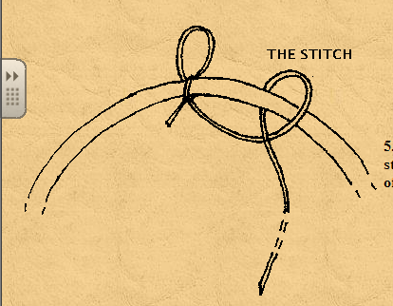
The dream catcher repeats the same stitch from start to finish. To start, hold the string and place it loosely over the top of the hoop. Move the string around to the back of the hoop (leaving a loop) and pull the string back to the front through the hole you just made.

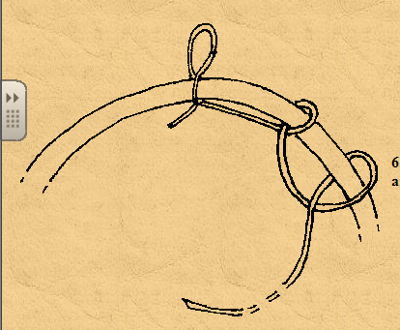

Pull each stitch tight. Slide the string to the right about 2 inches and wrap the string loosely over the top of the hoop and then down to the back leaving a hole. Pull the string back through the hole you just made from the back to the front. As you tighten this wrapping, slide the knot to the right 2 inches.

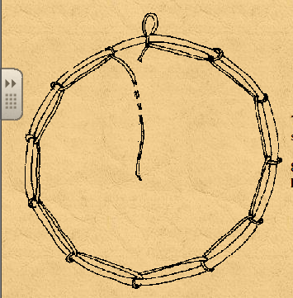
Continue the same stitch for the first round around the hoop. Space the stitches evenly about 2 inches apart (making 5 to 6 points on the hoop). The last stitch of the first round should be placed about a half inch away from the starting knot.

Stitch for the second round:
On the second round, place the string around the center of each previous stitch made from the first time around the hoop. Place the string loosely over the top of the loop of string. Move the string around to the back of the looped string (leaving a new loop shaped like a triangel) and pull the string back to the front through the hole you just made.

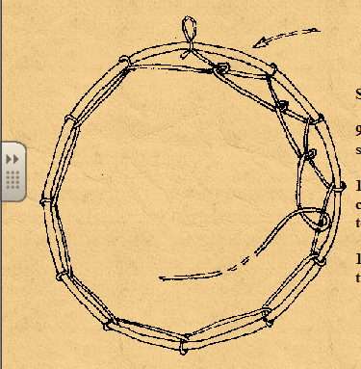

As you continue, you should see the spider web beginning to form. On the third or fourth round add a bead to represent the spider in the web. Simply place the bead on your string and continue stitching as usual.

